OMPE Compare Tool

Contents

Getting Started 1

What is OMPE Compare Tool? 1

System Requirements 1

Setting Up OMPE Compare Tool 2

Using OMPE Compare Tool 2

Input Options 2

REPORT Mode 2

HISTORY Mode 3

CSV Modes 3

Utility Statistics Mode 3

Output Options 4

RunID 4

Output Format 4

Parameters 4

Editing Parameters 5

REPORT column names 6

Remote Download Info 6

Generic Output Options 6

Accounting SECTIONS 7

Statistics SECTIONS 8

Buffer Pool 8

Accounting OPTIONS 9

Parameter Descriptions and Default Values 11

Running OMPE Compare Tool 14

# Getting Started

## What is OMPE Compare Tool?

OMPECmp is a tool for gathering and comparing data from OMPE reports. The purpose of this tool is to save time and effort in identifying and analyzing changes in OMPE data while maintaining portability and flexibility. The program calculates the % relative change between two input data sets and highlights data greater than a specified threshold. OMPECmp offers many different ways to compare data from both CSV and text inputs. It is also capable of generating reports in CSV, HTML, and XML formats, which means less dependency on proprietary software.

## System Requirements

* Java 1.7

## Setting Up OMPE Compare Tool

1. Extract the ZIP archive. It should contain ompecmp.jar, OMPECMP_env.xml, ompecmp.bat, and an Examples folder.
2. If you need to remotely access the files, ensure that you configure your firewall to allow access.
3. Run the JAR file. If the .JAR file will not itself execute, the .bat file can be used to start OMPE Compare Tool.

# Using OMPE Compare Tool

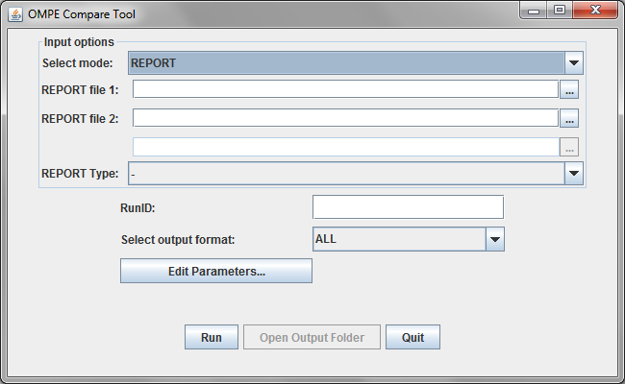

## Input Options

OMPE Compare Tool runs in four different modes: REPORT, CSV REPORT, HISTORY, and CSV HISTORY, which can be selected from the first combo box. To select input files, enter the file path into the text field or browse for the file by clicking on the button immediately adjacent to the field.

### REPORT Mode

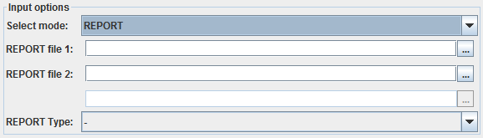

REPORT mode expects two input files. Data from each file will be compared side-by-side with a delta calculated between them. The first file will be considered the base values by which the deltas are calculated. The REPORT Type combo-box does not affect report processing, but configures the Parameters Editor to show the most relevant parameters when opened.

### HISTORY Mode

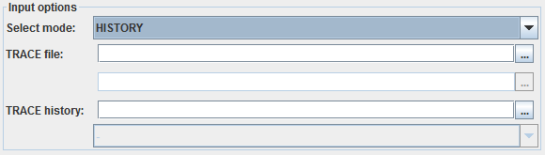

HISTORY mode expects at least one input TRACE file and (optionally) one TRACE history file of the type xxx_HIST.xml. Data in the input file will be added to the data in the history file. If no history file is provided, data from the TRACE file will be added to a new history file.

#### HISTORY MODE BATCH SUPPORT

In HISTORY mode, if multiple TRACE files are selected, OMPE Compare tool will sequentially process them and add them in turn to the history file. The resulting output file will contain TRACE data from all input TRACE files.

### CSV Modes

CSV REPORT and CSV HISTORY work exactly like REPORT and HISTORY but expect CSV input files.

### Utility Statistics Mode

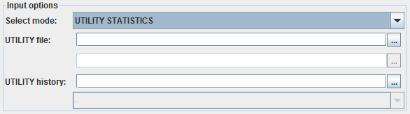

UTILITY STATISTICS mode expects at least one input utility statistics file and optionally one utility history file of the type xxx_US.xml. Data in the input file will be added to the data in the history file. If no history file is provided, data from the input file will be added to a new history file.

#### UTILITY STATISTICS MODE BATCH SUPPORT

In UTILITY STATISTICS mode, if multiple input files are provided, OMPE Compare tool will sequentially process them and add them in turn to the history file. The resulting output will contain utility statistics data from all input files.

## Output Options

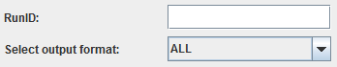

### RunID

If provided, RunID will determine the name given to the output files. If no RunID is provided, the name “output” will be used. For example, the RunID “example” will result in output files named example_AC.xml, example_ST.csv, or example_HIST.html depending on the type of report and format requested.

### Output Format

There are four choices of output format: ALL, XML, CSV, HTML. ALL will result in all three choices.

### Parameters

OMPE Compare Tool parameters can be set by clicking the “Edit Parameters...” button.

## Editing Parameters

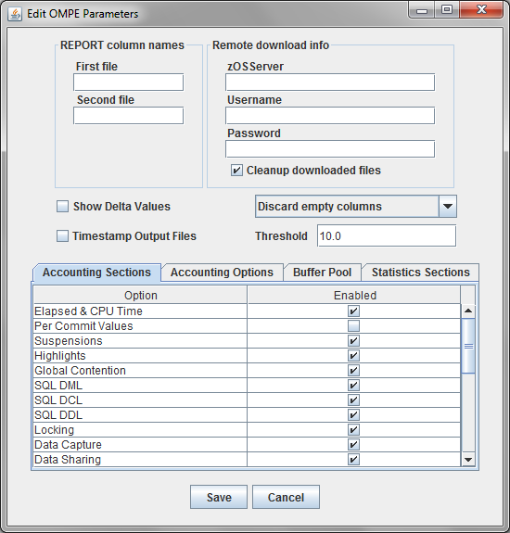

There are seven sections to the parameters window: Input file column names, Remote download info, Generic output options, Accounting, Statistics, Buffer Pool, and Accounting Jobs. The parameters are stored in a file named OMPECMP.parameters in the same directory as OMPECMP.jar. When no parameters file exists, a new one is created with default (mostly blank) options.

### REPORT column names

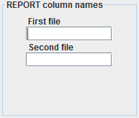

These options set the first and second column names of the output for REPORT and CSV REPORT mode. For example, if your first input file is a report for version 10 and the second a report for version 11, you may set “V10” and “V11” for the first file and second file fields respectively, and the output report will have the proper labels.

### Remote Download Info

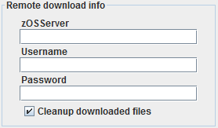

These options allow for the fetching of input files from a remote system such as STLMVS1.

### Generic Output Options

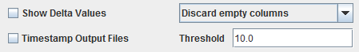

“Show Delta Values” shows the delta value between inputs in addition to the percent difference. If unchecked, the output only shows the percent difference.

The combo box presents three options. If set to “Discard empty columns”, output will not be shown with an empty DELTA(%) column. If set to “Discard columns below threshold”, output will not be shown when the DELTA(%) column is below the threshold set in the Threshold option in this section. “Show all columns” shows all of the data regardless of the value in the DELTA(%) column.

“Timestamp Output Files” adds a timestamp to the output file name of the format “MMddHHmm”.

### Accounting SECTIONS

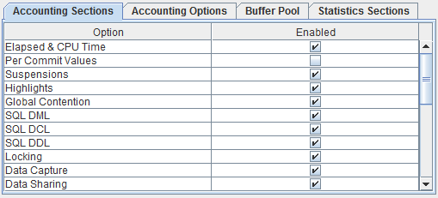

The Accounting Sections tab controls the accounting outputs.



The last two options behave differently from the rest. If neither box is checked, no package information will be displayed. If the first box is checked, package information will be displayed with the default naming. If the second box is checked, package information will be displayed with naming given by ACTIVITY_NAME. If both boxes are checked, the second box will be ignored.

#### Using the Packages Parameters

In the below example, the package name would be “SYSLN200” if Default Naming is selected or if neither is selected. If ACTIVITY NAME is selected, then the package name would be the data after ACTIVITY NAME except if it is 'BLANK', in which case it will use “SYSLN200.”

**A_packages=y or if ACTIVITY NAME = 'BLANK'**

SYSLN200  VALUE SYSLN200 TIMES SYSLN200 AVERAGE TIME AVG.EV TIME/EVENT

------------------ ------------------ ------------------ ------------ ------------------ ------------ ------ ------------

TYPE PACKAGE ELAP-CL7 TIME-AVG 0.007150 LOCK/LATCH 0.000015 0.06 0.000252

CP CPU TIME 0.000687 IRLM LOCK+LATCH 0.000015 0.01 0.001502

LOCATION DSNDA1B AGENT 0.000687 DB2 LATCH 0.000001 0.05 0.000018

COLLECTION ID NULLID PAR.TASKS 0.000000 SYNCHRONOUS I/O 0.005667 3.24 0.001750

PROGRAM NAME SYSLN200 SE CPU TIME 0.000000 OTHER READ I/O 0.000588 0.21 0.002842

SUSPENSION-CL8 0.006289 OTHER WRITE I/O 0.000019 0.00 0.011457

ACTIVITY TYPE NONNESTED AGENT 0.006289 SERV.TASK SWITCH 0.000000 0.00 0.001332

**A_packages=a**

ACTIVITY NAME 'BLANK' PAR.TASKS 0.000000 ARCH.LOG(QUIESCE) 0.000000 0.00 N/C

SCHEMA NAME 'BLANK' NOT ACCOUNTED 0.000175 ARCHIVE LOG READ 0.000000 0.00 N/C

SUCC AUTH CHECK 0 AVG.DB2 ENTRY/EXIT N/P DRAIN LOCK 0.000000 0.00 N/C

OCCURRENCES 695780 DB2 ENTRY/EXIT N/P CLAIM RELEASE 0.000000 0.00 N/C

NBR OF ALLOCATIONS 3478 PAGE LATCH 0.000000 0.00 0.000100

SQL STMT - AVERAGE N/P CP CPU SU 39.10 NOTIFY MESSAGES 0.000000 0.00 N/C

SQL STMT - TOTAL N/P AGENT 39.10 GLOBAL CONTENTION 0.000000 0.00 N/C

NBR RLUP THREADS 695612 PAR.TASKS 0.00 TCP/IP LOB XML 0.000000 0.00 N/C

SE CPU SU 0.00 TOTAL CL8 SUSPENS. 0.006289 3.51 0.001793

### Statistics SECTIONS

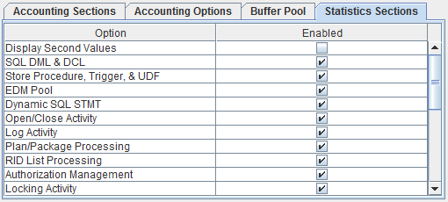

The Statistics Sections tab controls the statistics options.

### Buffer Pool

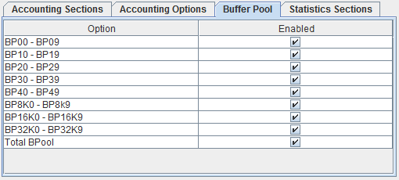

The Buffer Pool tab controls the Buffer Pool settings.

### Accounting OPTIONS

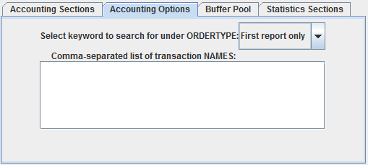

The Accounting Options tab consists of two options. The first combo box allows the selection of 10 different options, CONNTYPE, PLANNAME, AUTHID, CORRNAME, ACTNAME, PACKAGE, PROGRAM, INTERVAL, TRANSACT, and First report only. The text field allows the user to list a series of NAMES for the ORDERTYPE..

#### Using ORDERTYPE and NAMES parameters

These parameters should only be used when the user wishes to process the reports by CONNTYPE, PLANNAME, AUTHID, CORRNAME, ACTNAME, PACKAGE, PROGRAM, INTERVAL, or TRANSACT names. For instance, suppose we have an input file that has multiple CONNTYPE reports in it. Suppose the CONNTYPE for each report in the file are shown below.

1 LOCATION: DSNDA1B OMEGAMON XE FOR DB2 PERFORMANCE EXPERT (V5R1)

GROUP: N/P ACCOUNTING REPORT - LONG

MEMBER: N/P

SUBSYSTEM: DA1B ORDER: CONNTYPE

DB2 VERSION: V10 SCOPE: MEMBER

CONNTYPE: DRDA

...............DATA HERE......................

1 LOCATION: DSNDA1B OMEGAMON XE FOR DB2 PERFORMANCE EXPERT (V5R1)

GROUP: N/P ACCOUNTING REPORT - LONG

MEMBER: N/P

SUBSYSTEM: DA1B ORDER: CONNTYPE

DB2 VERSION: V10 SCOPE: MEMBER

CONNTYPE: CICS

...............DATA HERE......................

1 LOCATION: DSNDA1B OMEGAMON XE FOR DB2 PERFORMANCE EXPERT (V5R1)

GROUP: N/P ACCOUNTING REPORT - LONG

MEMBER: N/P

SUBSYSTEM: DA1B ORDER: CONNTYPE

DB2 VERSION: V10 SCOPE: MEMBER

CONNTYPE: RRS

...............DATA HERE......................

If we suppose there is another input file with the same report headers and wish to compare the reports from different files with matching CONNTYPE, then we must set ORDERTYPE=CONNTYPE

|  |  |  |  |
| --- | --- | --- | --- |
| **DRDA** |  |  |  |
| **Section** | **V10** | **V11** | **Delta (%)** |
| Row Name | Data | Data | Delta |
| Row Name | Data | Data | Delta |
| **Section** | **V10** | **V11** | **Delta (%)** |
| Row Name | Data | Data | Delta |
| **CICS** |  |  |  |
| **Section** | **V10** | **V11** | **Delta (%)** |
| Row Name | Data | Data | Delta |
| Row Name | Data | Data | Delta |
| **Section** | **V10** | **V11** | **Delta (%)** |
| Row Name | Data | Data | Delta |

If you want to compare only the CNNTYPE DRDA and CICS, in the NAMES box enter:

DRDA, CICS

In this case, the CONNTYPE RRS will be excluded from the resulting report. In this way, you can selectively compare a specific list of names (planname/authid/etc.) under an ORDERTYPE.

### Parameter Descriptions and Default Values

| **Parameter** | **Description** | **Default Setting** |
| --- | --- | --- |
| **Input file column names** | | |
| First file | Column name for the first input file. In TRACE mode, it is the column name for the new data specified by the input file, and all data from the history file will remain unchanged. (ignored in CSV mode) |  |
| Second file | Column name of the second input file (ignored in TRACE and CSV mode) |  |
| **Remote download info** | | |
| zOSServer | Server name from which to download the input files |  |
| Username | Username for authentication at server |  |
| Password | Password for authentication at server |  |
| Cleanup downloaded files | Delete downloaded files after we are done using them | y |
| **Output parameters** | | |
| Threshold | Percent tolerance for marking data. Data with delta (%) > tolerance will have warning level “med” and data with delta (%) > 2*tolerance will have warning level “high”. Otherwise the warning level will be “low” | 10 |
| Combo box | If set to “Discard empty columns”, output will not be shown with an empty DELTA(%) column. If set to “Discard columns below threshold”, output will not be shown when the DELTA(%) column is below the threshold set in the Threshold option in this section. “Show all columns” shows all of the data regardless of the value in the DELTA(%) column. | Discard empty columns |
| ShowDelta | Determines whether the delta value (set1-set0) will be displayed. Ignored in TRACE mode. When this equals “y” delta and delta(%) will be displayed. When this equals “n” only delta(%) will be displayed. | n |
| **Accounting Report Parameters** | | |
| Per Commit Values | Changes all counters in the accounting report to their per commit values (not used in TRACE mode) | n |
| Elapsed Time |  | y |
| Suspensions |  | y |
| Highlights |  | y |
| Global Contention |  | y |
| SQL DML |  | y |
| SQL DCL |  | y |
| SQL DDL |  | y |
| Locking |  | y |
| Data capture |  | y |
| Data Sharing |  | y |
| Query Parallel |  | y |
| Store Procedure |  | y |
| UDF |  | y |
| Row ID |  | y |
| RID List |  | y |
| Average SU |  | y |
| Logging |  | y |
| Dynamic SQL |  | y |
| Buffer Pool |  | y |
| Group Buffer Pool |  | y |
| Triggers |  | y |
| Distributed Activity |  | y |
| Accelerator |  | y |
| Packages | See “Using the packages parameters” section | n |
| **Statistics Report Parameters** | | |
| Display Second Values | Display the per-second values for the rows | n |
| SQL DML & DCL |  | y |
| Store Procedure, Trigger, and UDF |  | y |
| EDM Pool |  | y |
| Dynamic SQL STMT |  | y |
| Open/Close Activity |  | y |
| Log Activity |  | y |
| Plan/Package Processing |  | y |
| RID List Processing |  | y |
| Authorization Management |  | y |
| Locking Activity |  | y |
| Global DDF Activity |  | y |
| CPU Times |  | y |
| Data Capture |  | y |
| IFC Record |  | y |
| Latch |  | y |
| DBM1 & MVS Storage Below 2GB |  | y |
| DBM1 & MVS Storage Above 2GB |  | y |
| DIST and MVS Storage |  | y |
| Real and Auxiliary Storage for DBM1 |  | y |
| Real and Auxiliary Storage for DIST |  | y |
| Common Storage Below and Above 2GB |  | y |
| Work File Database |  | y |
| Buffer Pool |  | y |
| Group Buffer Pool |  | y |
| **Buffer Pool Settings** | | |
| BP00 - BP09 |  | y |
| BP10 - BP19 |  | y |
| BP20 - BP29 |  | y |
| BP30 - BP39 |  | y |
| BP40 - BP49 |  | y |
| BP8K0 - BP8K9 |  | y |
| BP16K0 - BP16K9 |  | y |
| BP32K0 - BP32K9 |  | y |
| Total BPool |  | y |
| **Accounting Jobs** | | |
| ORDERTYPE | If there are multiple reports in the input file we can separate them by ORDERTYPE. Valid ORDERTYPE values are CONNTYPE, PLANNAME, AUTHID, CORRNAME, ACTNAME, PACKAGE, PROGRAM, INTERVAL, and TRANSACT, and First report only. |  |
| NAMES | This restricts the input reports (separated by commas) that will appear in the output report. If it is blank, all input reports will be displayed. For instance, if ORDERTYPE = CORRNAME and NAMES=THQ11, THQ12, THQ13 then only reports containing CORRNAME: THQ11, CORRNAME: THQ12, or CORRNAME: THQ13 will appear in the program output. |  |

## Running OMPE Compare Tool



When OMPE Compare Tool has been properly configured, hit the “Run” button to run the compare operation and output the results. If any errors occur, a dialog box will be displayed to show them. If the output is successfully generated, the “Open Output Folder” button will be displayed to allow easy access to the output files. The output files will be placed in the same directory as the OMPE Compare Tool .JAR file.

OMPE Compare Tool outputs certain debug and log messages to standard output, and these can be viewed if necessary by launching the .JAR file from a command line.